**WordPress site**

I thought of creating a **New Year eve** on behalf of an event organiser called **“Local Denmark**”, where the Interested persons can register and can celebrate the new year with a group of people in the heart of the city.

Here's the eve's site structure. Website url is below.

**http://dev-new-year-eve.pantheonsite.io**

**Creating pages for site**

**Website>dashboard**

* Creating pages for the site **dashboard>Pages>add new**>and added a **home page**, information **about page** the event, **Program Plan page**, and **Registration** page.

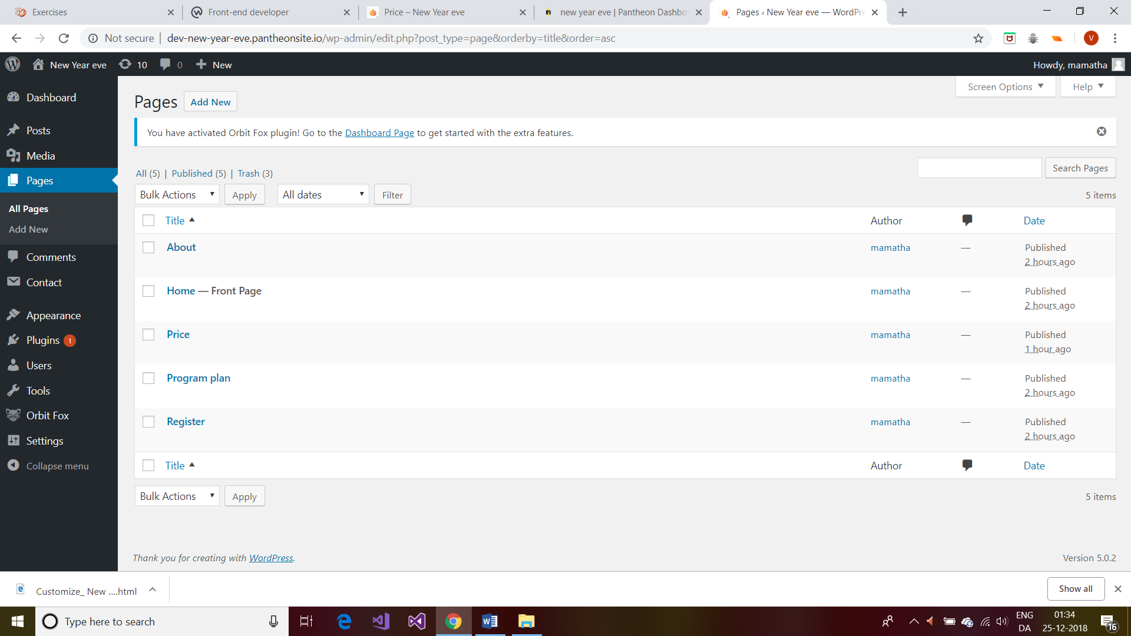

To make the Home page i just created the main landing page, navigate to **Settings > Reading>select a static page and homepage as home>save settings**

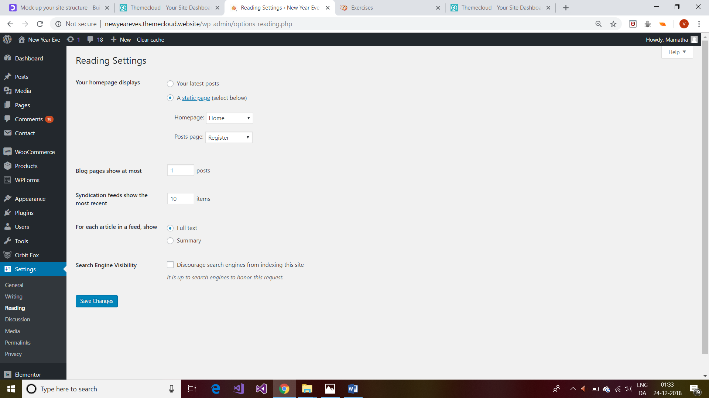

**The content of my About >edit/enter**

and enter the content of page as below and on left hand side just click **update/publish** s that the content is ready for webpage

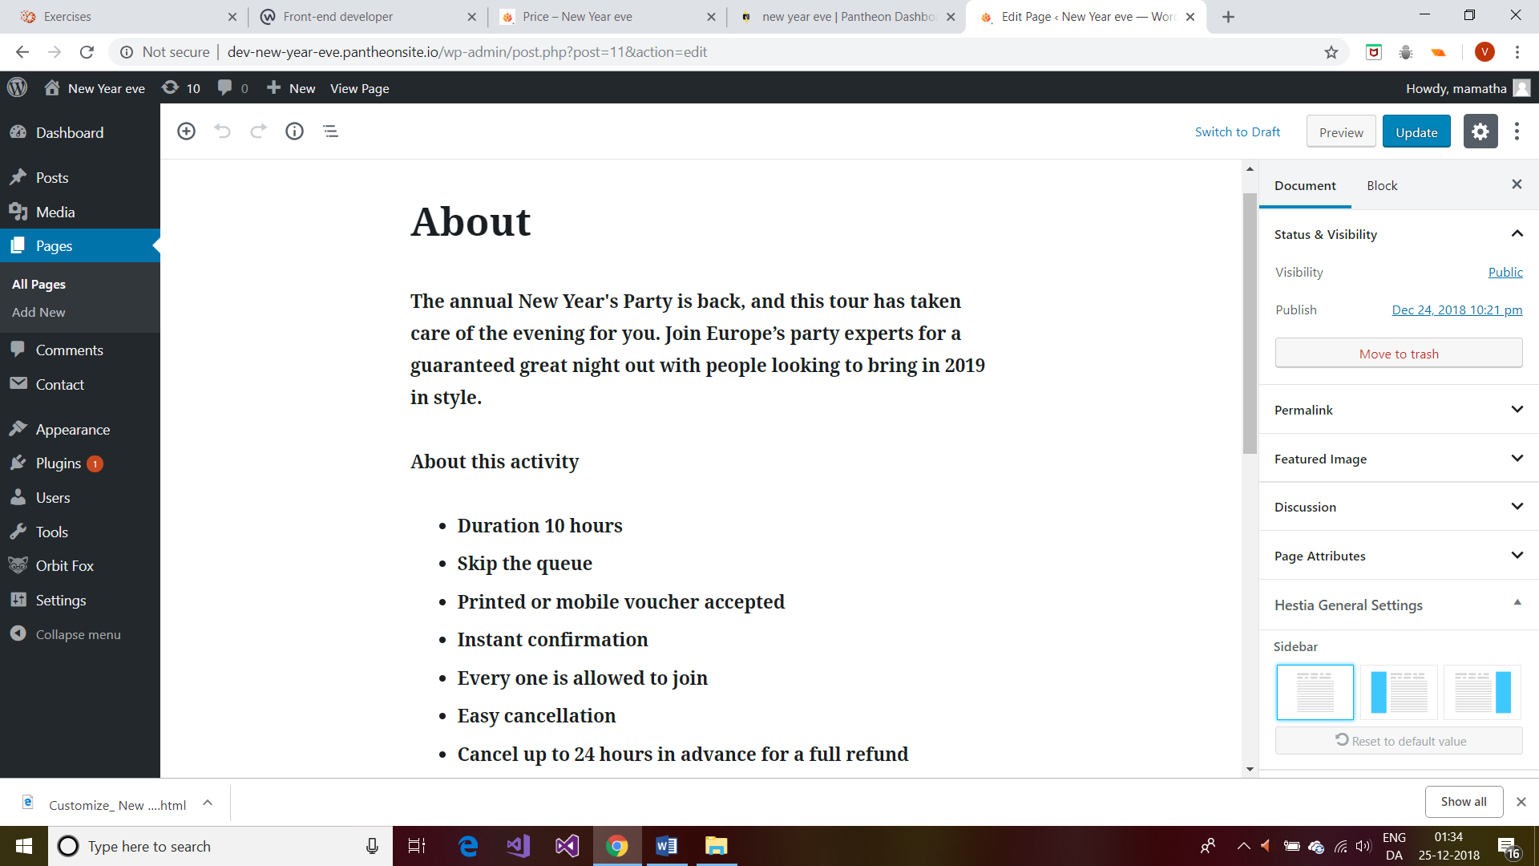

And similarly **program plan page**

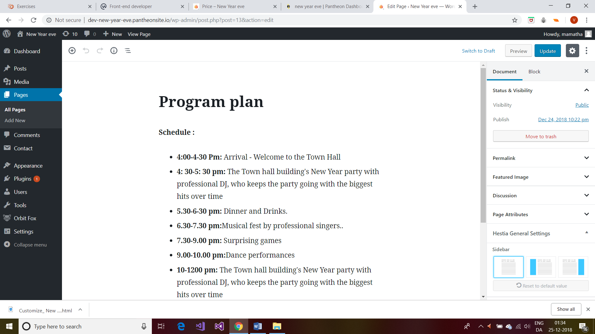

**Registration** page where I have  **a form(widget/plugin) link** so that the interested persons can fill out and send to register their place in the new year event.

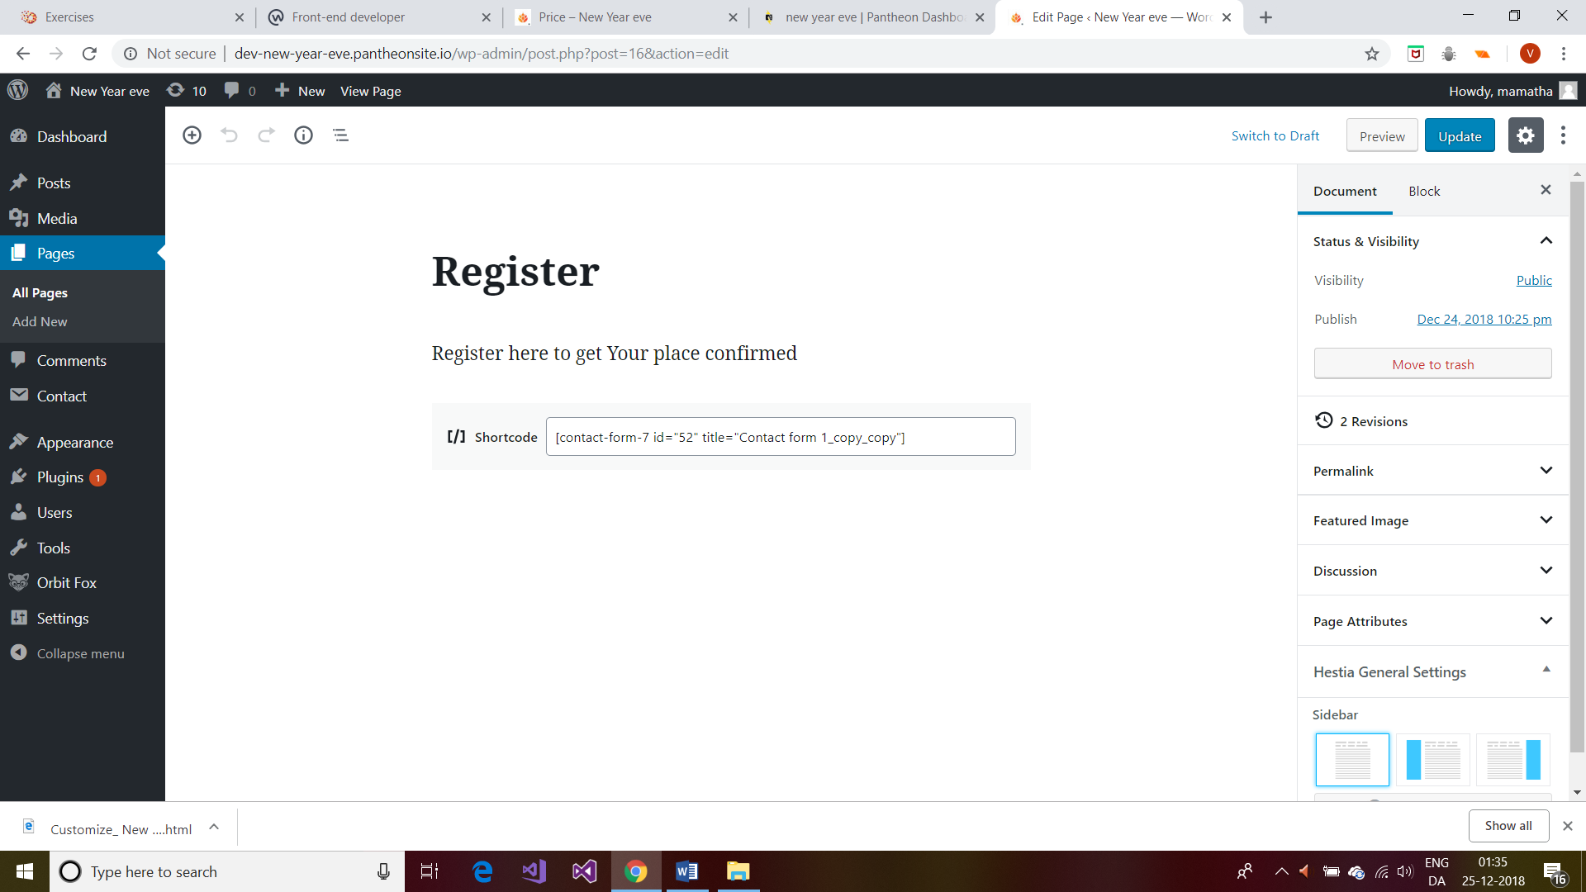

**Price** page I have designed as below

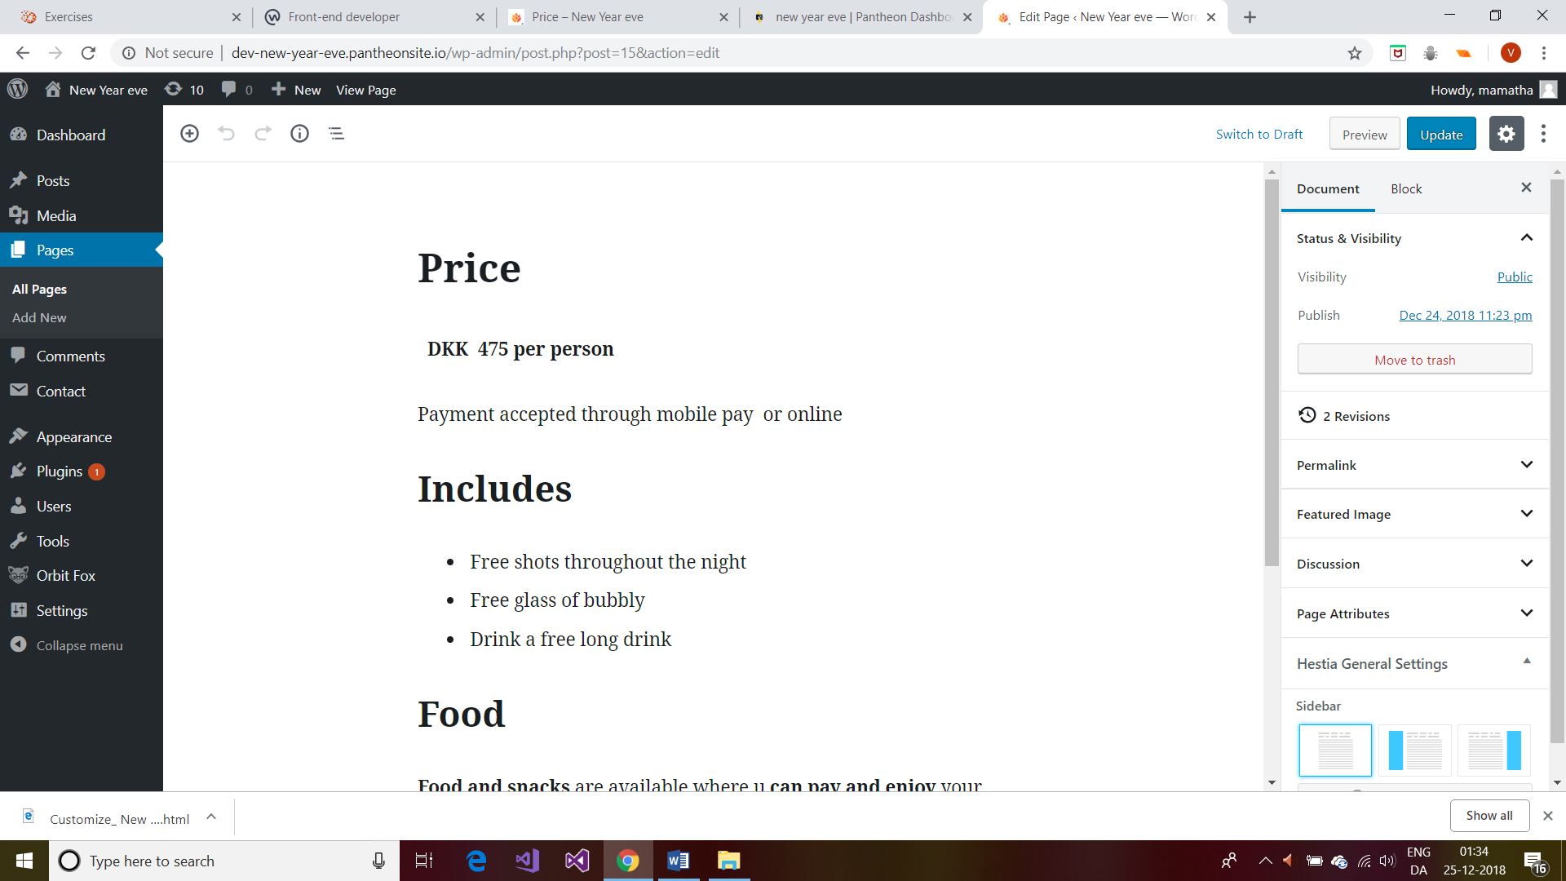

**Integrating a theme**

**Dashboard>appearances>themes>add new>popular>Hestia>install>activate>customize**

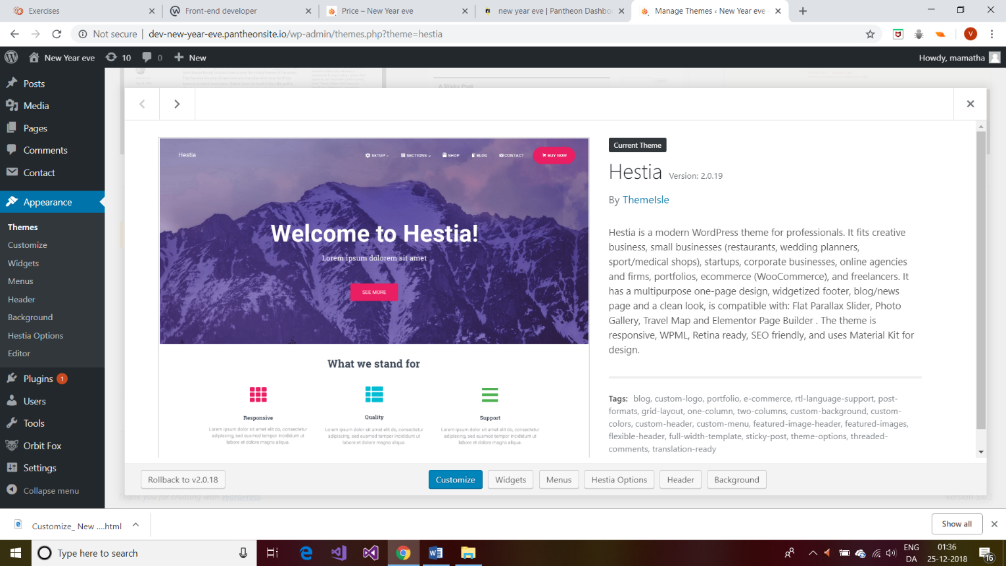

**Activate>install** so that it installed the theme

**Customising the theme**

* + **Dashboard>Appearances>customize>site identity** and changed the **logo>change logo** and **site icon >change image to** images to a what I have downloaded from google (can see 2019 logo and in down a flower image for site logo) **>publish**
  + **Font page section>big title section>big title back ground image>to one of my downloaded images, title: new year eve,**

**text: at town hall square button: register>publish**

* + **Font page section>except big title section and contact section I deselected all the section>publish**
  + **Appearance>** **font size>Big title section>9(increased by 25)>publish**
  + **Colours>accent colour>changed to #d81c54** (u can absorb by muse over on navigation menu) **>publish**
  + **Menus>create new menu>menu name nav bar>menu location>select all 3>next>add items>selected the pages home, about, program plan, register, price>publish**
  + **Header options>heading settings>header gradient>red(I choose) >publish**
  + **Customise>widgets>footer one>text: contact us (I gave some address)**

And then for calendar widget **click on add widget>selected calendar>text: gave some text>publish**

* + **Homepage settings>home page display>static and select homepage>home>publish**

**After customising all above settings Finally my outcome is shown as below(it’s a home age also)**

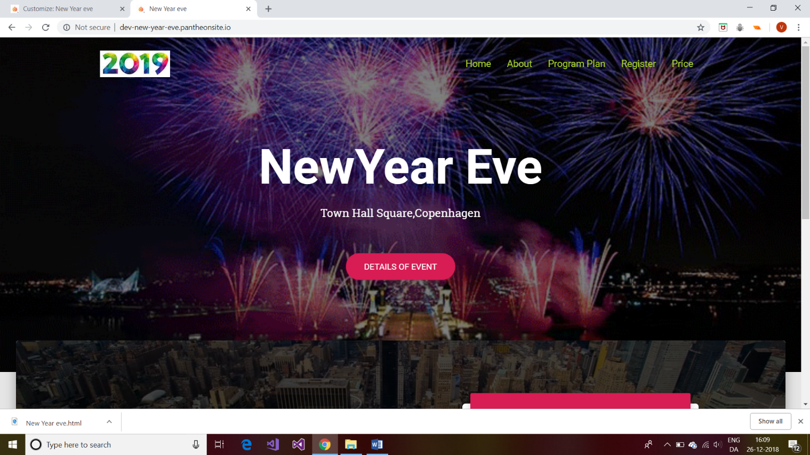

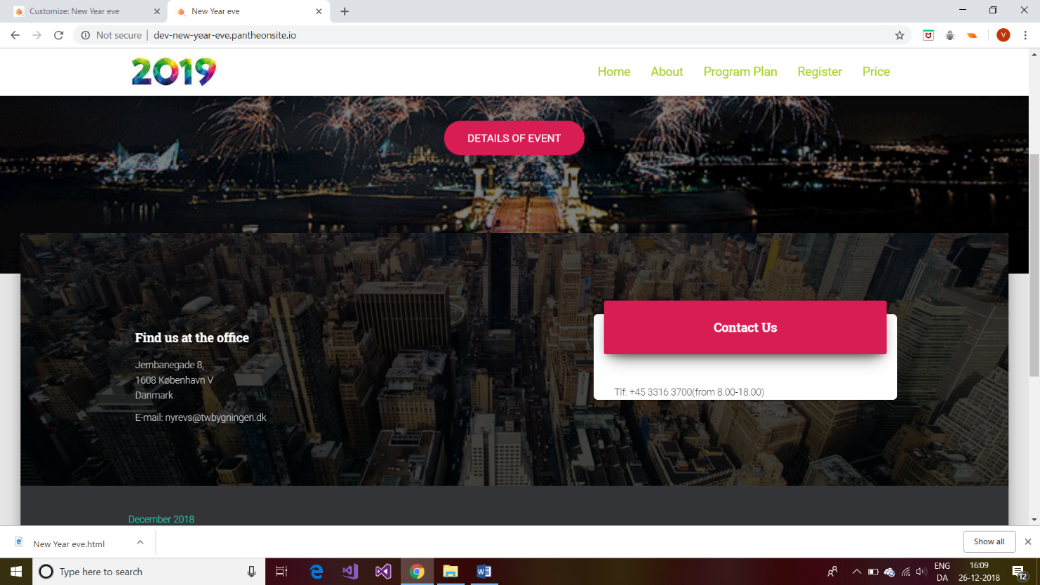

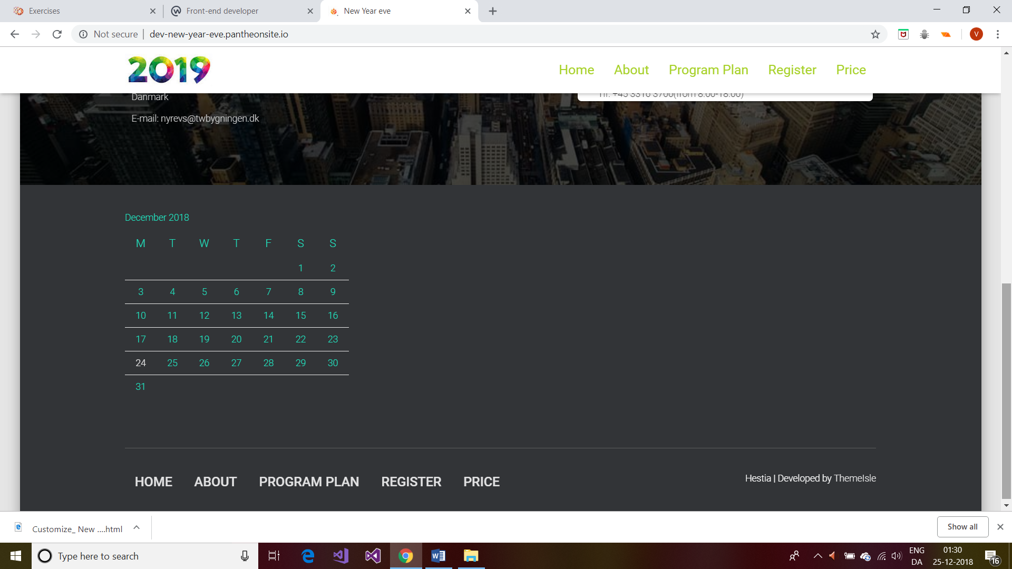

**Editing (inner working of form)**

I thought of having a register form in my register page and of having some fields in it

In new year eve>dashboard>plugin>add new>in search I typed contact form>selected contact form 7>Install now>activate

After that u can see that in my list of plugins

So selected contact form 7>settings>contact form (selected it) and edited html with extra textboxes and like no.of persons,

Now copy the short code and paste in the register page i.e. copy code and now click on dashboard>pages> all pages>select register>edit>and paste the code>update

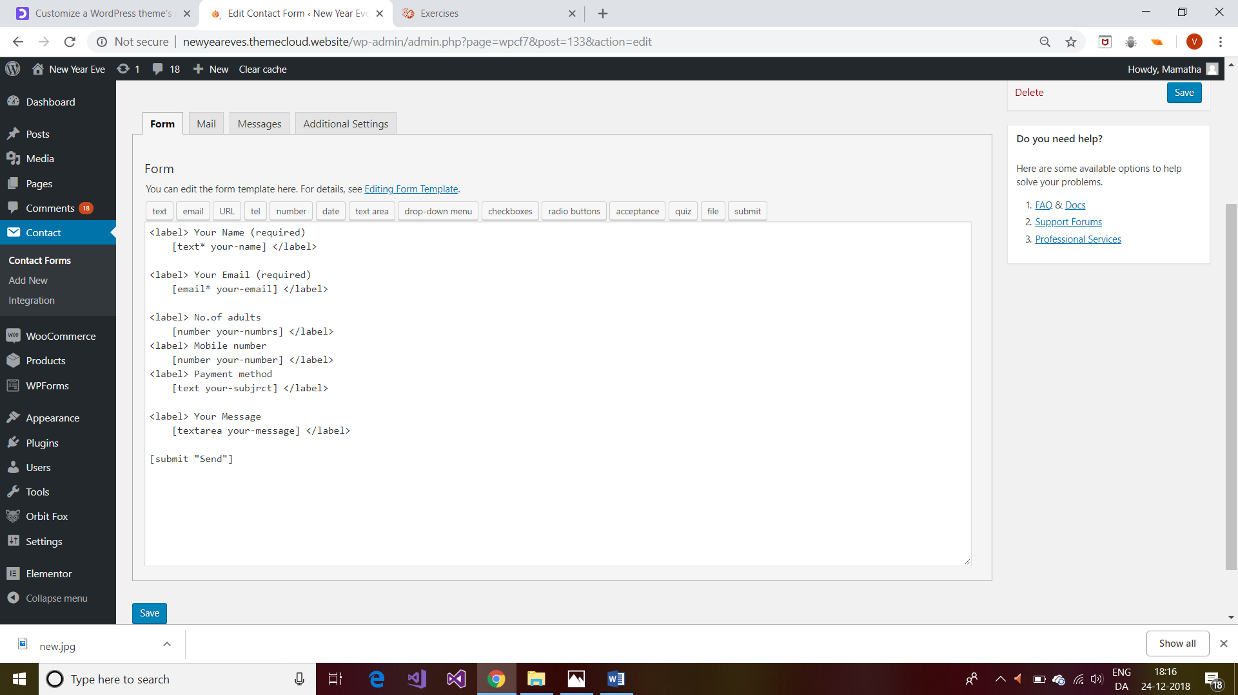

**Modifications to theme with CSS**

**Dashboard>appearances>customize>additional CSS**

I want to change the size of nav items because they are so small

So, I included the following code**>publish**

. navbar .navbar-nav>li>a {

padding-top: 15px;

padding-bottom: 15px;

border-radius: 3px;

**color: #a7d129**;(**I changed green colour before it was black )**

**text-transform: capitalize;(before it was in uppercase**)

}

.navbar-default .navbar-nav>li>a:hover, .navbar-default .navbar-nav>li>a:focus {

**background-color:black;**

**text-decoration:underline;(underline when mouse hover on pages)**

}

. navbar, navbar a, .label, .footer .footer-menu a, .media-footer a, .hestia-top-bar {

**font-size**: **20px;(before it was 12 px)**

}

//changing the colour of calendar heading content colour

. footer-big {

**color: #21e6c1;**

}

caption {

padding-top: 8px;

padding-bottom: 8px;

**color: #21e6c1;**

text-align: left;

}

code {

padding: 2px 4px;

font-size: 90%;

**color: blue;**

background-color: white;

border-radius: 4px;

}

